Embedded System’s Security: HackRF & GNU Radio Companion Setup

Hardware Assembly

The HackRF kit includes the SDR, a micro-USB to USB cable and an antenna. Screw on the antenna and connect the device to your computer via the USB cable.

When the USB port is connected on the side the Hack RF should light up, indicating it is on, like so:

Hack RF Installation

Ensure that your hack RF is plugged in. Downloading Pothos SDR will setup the Hack RF and import a couple useful modules. Head to the following link to begin the download.

<https://downloads.myriadrf.org/builds/PothosSDR/PothosSDR-2021.07.25-vc16-x64.exe>

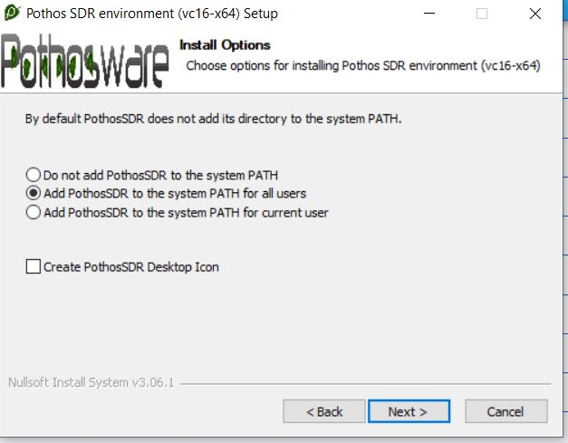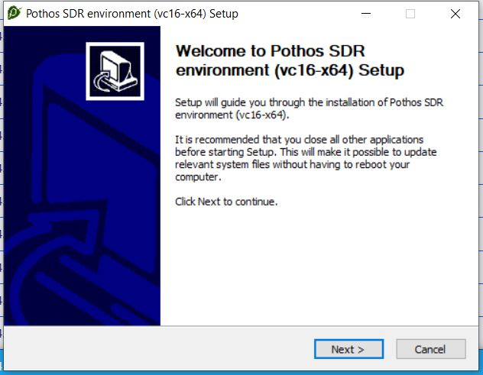When finished downloading, open the .exe and proceed with the installation by clicking the *next* button. When asked if Pothos should be added to the system variables, select *Add PothosSDR to the system PATH for all users*.

Continue with the Pothos installation, leaving all the selected components as default.

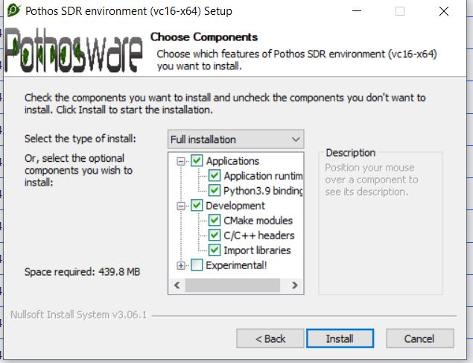

When you complete the installation the Hack RF should be successfully setup. To test this, first reset your Hack RF by clicking the button furthest from the antenna. Open the CMD on your computer and type in the following command.

***hackrf_info***

You should have a result similar to the screenshot. If the command does not work then most likely the Hack RF setup has failed, and if a system restart does not help then you can try the other Hack RF setup document.

GNU Companion

Use the following link to download the GNU Companion installer, open the .exe file when the download is complete.

<http://www.gcndevelopment.com/gnuradio/downloads/installers/v1.6.0/gnuradio_3.7.13.5_win64.msi>

Continue through the installation windows by clicking the *next* button and leaving all settings as default.

When complete, open the GNU Radio Companion application and you should see the template window with *Options* and Variable blocks. This concludes the HackRF & GNU Radio Companion Setup.

